Space News Update – July 2015
By Pat Williams
IN THIS EDITION:
- Three billion-mile journey to Pluto.
- Charon’s surprising, youthful and varied terrain.
- Science on the surface of Comet 67P/Churyumov–Gerasimenko.
- Testing asteroid prospecting technology.
- Radar guards against space debris.
- Global space economy climbs to $330 billion.
- Links to other space and astronomy news published in July 2015
Disclaimer - I claim no authorship for the printed material; except where noted.

THREE-BILLION-MILE JOURNEY TO PLUTO

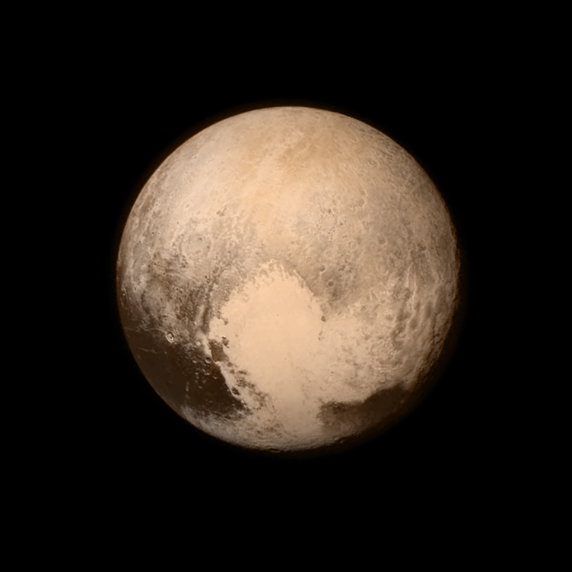
Pluto nearly fills the frame in this image from the Long Range Reconnaissance Imager (LORRI) aboard NASA’s New Horizons spacecraft, taken on July 13, 2015 when the spacecraft was 476,000 miles (768,000 kilometers) from the surface. This is the last and most detailed image sent to Earth before the spacecraft’s closest approach to Pluto on July 14. The color image has been combined with lower-resolution color information from the Ralph instrument that was acquired earlier on July 13. This view is dominated by the large, bright feature informally named the “heart,” which measures approximately 1,000 miles (1,600 kilometers) across. The heart borders darker equatorial terrains, and the mottled terrain to its east (right) are complex. However, even at this resolution, much of the heart’s interior appears remarkably featureless—possibly a sign of ongoing geologic processes.
Credits: NASA/APL/SwRI

After a decade-long journey through our solar system, New Horizons made its closest approach to Pluto Tuesday, about 7,750 miles above the surface - roughly the same distance from New York to Mumbai, India - making it the first-ever space mission to explore a world so far from Earth. Three-billion-mile journey to Pluto (14 July 2015)

CHARON’S SURPRISING, YOUTHFUL AND VARIED TERRAIN

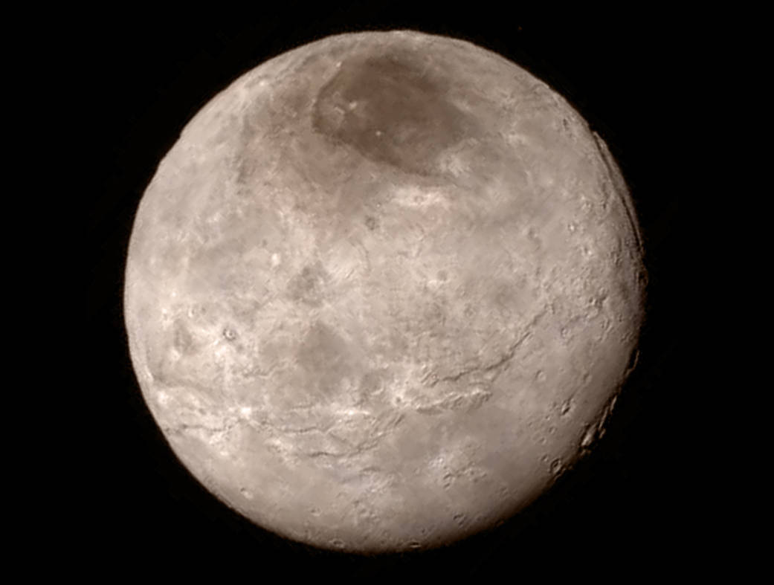
Image Credit: NASA-JHUAPL-SwRI

Remarkable new details of Pluto’s largest moon Charon are revealed in this image from New Horizons’ Long Range Reconnaissance Imager (LORRI), taken late on July 13, 2015 from a distance of 289,000 miles (466,000 kilometers).
A swath of cliffs and troughs stretches about 600 miles (1,000 kilometers) from left to right, suggesting widespread fracturing of Charon’s crust, likely a result of internal processes. At upper right, along the moon’s curving edge, is a canyon estimated to be 4 to 6 miles (7 to 9 kilometers) deep.
Mission scientists are surprised by the apparent lack of craters on Charon. South of the moon’s equator, at the bottom of this image, terrain is lit by the slanting rays of the sun, creating shadows that make it easier to distinguish topography. Even here, however, relatively few craters are visible, indicating a relatively young surface that has been reshaped by geologic activity.
In Charon’s North Polar Region, a dark marking prominent in New Horizons’ approach images is now seen to have a diffuse boundary, suggesting it is a thin deposit of dark material. Underlying it is a distinct, sharply bounded, angular feature; higher resolution images still to come are expected to shed more light on this enigmatic region.
The image has been compressed to reduce its file size for transmission to Earth. In high-contrast areas of the image, features as small as 3 miles (5 kilometers) across can be seen. Some lower-contrast detail is obscured by the compression of the image, which may make some areas appear smoother than they really are. The uncompressed version still resides in New Horizons’ computer memory and is scheduled to be transmitted at a later date. The image has been combined with color information obtained by New Horizons’ Ralph instrument on July 13. Charon’s surprising, youthful and varied terrain (15 July 2015)

SCIENCE ON THE SURFACE OF A COMET
Complex molecules that could be key building blocks of life, the daily rise and fall of temperature, and an assessment of the surface properties and internal structure of the comet are just some of the highlights of the first scientific analysis of the data returned by Rosetta’s lander Philae last November.

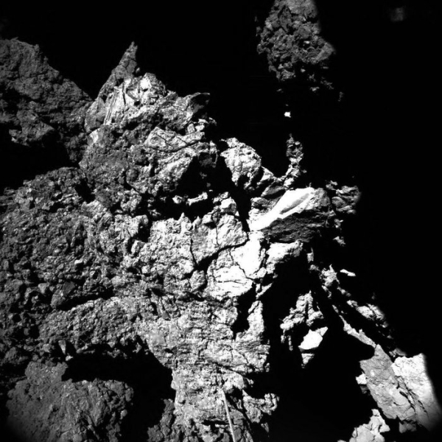 This well-lit image was acquired by Philae’s CIVA camera 4 at the final landing site Abydos, on the small lobe of Comet 67P/Churyumov–Gerasimenko, on 13 November 2014. The image shows one of the CONSERT antennas in the foreground, which seems to be in contact with the nucleus. The dimensions of the antenna, 5 mm in diameter and 693 mm long, help to provide a scale to the image. The pebble-like features, blocks and cliffs observed in the CIVA images corresponds to what has been seen at larger scales from orbit. A large range of brightness is also seen, perhaps associated with different mineral compositions. (courtesy: ESA/Rosetta/Philae/CIVA)
Data were obtained during the lander’s seven-hour descent to its first touchdown at the Agilkia landing site, which then triggered the start of a sequence of predefined experiments. But shortly after touchdown, it became apparent that Philae had rebounded and so a number of measurements were carried out as the lander took flight for an additional two hours some 100 m above the comet, before finally landing at Abydos.
Some 80% of the first science sequence was completed in the 64 hours following separation before Philae fell into hibernation, with the unexpected bonus that data were ultimately collected at more than one location, allowing comparisons between the touchdown sites.
After the first touchdown at Agilkia, the gas-sniffing instruments Ptolemy and COSAC analysed samples entering the lander and determined the chemical composition of the comet’s gas and dust, important tracers of the raw materials present in the early Solar System. COSAC analysed samples entering tubes at the bottom of the lander kicked up during the first touchdown, dominated by the volatile ingredients of ice-poor dust grains. This revealed a suite of 16 organic compounds comprising numerous carbon and nitrogen-rich compounds, including four compounds – methyl isocyanate, acetone, propionaldehyde and acetamide – that have never before been detected in comets. Meanwhile, Ptolemy sampled ambient gas entering tubes at the top of the lander and detected the main components of coma gases – water vapour, carbon monoxide and carbon dioxide, along with smaller amounts of carbon-bearing organic compounds, including formaldehyde. Importantly, some of these compounds detected by Ptolemy and COSAC play a key role in the prebiotic synthesis of amino acids, sugars and nucleobases: the ingredients for life. For example, formaldehyde is implicated in the formation of ribose, which ultimately features in molecules like DNA. The existence of such complex molecules in a comet, a relic of the early Solar System, imply that chemical processes at work during that time could have played a key role in fostering the formation of prebiotic material. Science on the surface of a comet (30 July 2015)

TESTING ASTEROID PROSPECTING TECHNOLOGY

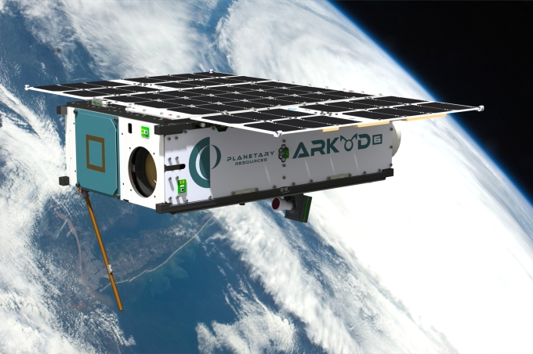 Arkyd 6, launching later this year.
Planetary Resources announced today that its Arkyd 3 Reflight (A3R) spacecraft deployed successfully from the International Space Station’s (ISS) Kibo airlock and has begun its 90-day
mission. Planetary Resources, Inc. was founded in 2009 by Eric Anderson and Dr Peter H. Diamandis. Our vision is to establish a new paradigm for resource utilization that will bring the Solar System within humanity’s economic sphere of influence. The company will conduct low-cost robotic space exploration beginning with the Arkyd series of space missions that will identify the most commercially viable near-Earth asteroids. These initial missions will assist the company in enabling the retrieval of raw materials from these select asteroids, including water, precious metals and more.
Peter H. Diamandis, M.D., co-founder and co-chairman, Planetary Resources, Inc., stated, “The successful deployment of the A3R is a significant milestone for Planetary Resources as we forge a path toward prospecting resource-rich asteroids. Our team is developing the technology that will enable humanity to create an off-planet economy that will fundamentally change the way we live on Earth.”
Once the A3R completes its mission, the validated and evolved technologies will be the main components of the Arkyd series of deep-space asteroid-prospecting spacecraft. The next demonstrator, the Arkyd-6 (A6), is scheduled to launch later this year and will test the next generation of attitude control, power, communication and avionics systems and also add sensors for detection and characterization of resources.
Planetary Resources is leveraging the increased payload capacity of the A6 to begin demonstration of core technology to measure resources on water-rich asteroids. Included in the payload is a mid-wave infrared imaging system, able to precisely measure temperature differences of the objects it observes, as well as acquire key data related to the presence of water and water-bearing minerals. The system will first test targeted areas of our own planet before being deployed to near-Earth asteroids on future missions.
Eric Anderson, co-founder and co-chairman, Planetary Resources, Inc., said, “This key technology for determining resources on asteroids can also be applied towards monitoring and managing high-value resources on our home planet. All of our work at Planetary Resources is laying the foundation to better manage and increase humanity’s access to natural resources on our planet and in our Solar System.” Planetary Resources’ first spacecraft deployed, testing asteroid prospecting technology on orbit (16 July 2015)

RADAR GUARDS AGAINST SPACE DEBRIS

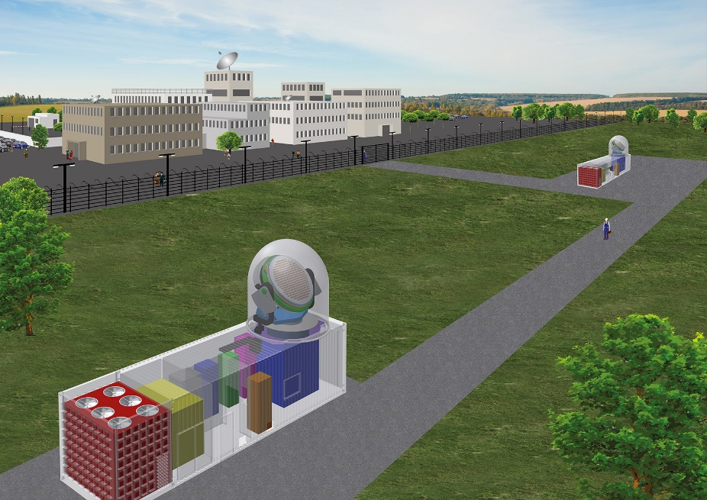
Both the transmitting and receiving antennas are fully retractable.
© Fraunhofer FHR

Space debris poses a growing threat to satellites and other spacecraft, which could be damaged in the event of a collision.

Traffic congestion is also an issue in space where, in addition to the dense network of satellites, orbiting space debris is increasingly transforming the paths on which they travel into a junkyard populated with burnt-out rocket stages and fragments of disintegrated spacecraft. Scientists estimate that there are now some 20,000 particles of space junk measuring more than ten centimeters in diameter hurtling around Earth at an average velocity of 25,000 kilometers per hour, not counting the 700,000 or so particles with a diameter of between one and ten centimeters. Although small, these items of space debris are traveling so fast that they could easily damage or destroy an operational satellite. The situation is exacerbated by the fact that space debris has a tendency to multiply exponentially through a kind of snowball effect. Whenever two particles collide, they break up into a greater number of smaller particles. Unless preventive measures are taken, the rapid multiplication of space debris could soon put an end to spaceflight as we know it. What is required is a radar system for monitoring and tracking objects in low-Earth orbit. This is the region of space in which the risk of collisions is at its greatest – especially at an altitude of 800 kilometers above Earth. Radar guards against space debris (1 July 2015)

SPACE ECONOMY – GLOBAL

Space Foundation report reveals global space economy climb to $330 billion. The Space Foundation today released the findings of its publication The Space Report 2015: The Authoritative Guide to Global Space Activity.
In 2014, the global space economy grew slightly more than 9 percent, reaching a total of $330 billion worldwide, up from 2013's $302.5 billion. Together, commercial space activities made up 76 percent of the global space economy. The industry as a whole demonstrated a compound annual growth rate (CAGR) of seven percent from 2005 to 2014, nearly doubling in size over the course of the decade.
U.S. government space spending went up slightly, 2.9 percent, from 2013 to 2014. The U.S. devoted 1.2 percent of the government's national budget to space in 2014. During that year, U.S. government space spending made up more than half of what all governments around the world spent on space. Space expenditures by governments other than the U.S. grew 12.9 percent in 2014, in spite of decreases in budgets of international cooperative efforts such as the European Space Agency.
Space Economy
In 2014, global navigation satellite system receivers, such as the ones integrated with smartphone microchips, were the primary driver behind a nearly 18 percent increase in revenue for commercial space infrastructure and support industries. More than 3 billion mobile devices receive signals, not only from U.S. GPS satellites, but also from the Russian GLONASS and a variety of satellite-based augmentation systems. About 2.8 billion location-based application services were downloaded to these mobile devices during 2014.
The overall value of satellites launched in 2014 decreased by 13.6 percent from 2013, partly driven by decreases in the number of high-value military satellite launches.
Launches and Satellites
There were 23 orbital space launch vehicles launched from the U.S. in 2014, four more than were launched in 2013. Europe launched 11 rockets, a 57 percent increase from the seven launched in 2013. Russia still conducts more launches than any other country, although its 2014 tally of 32 was the same as in 2013. The total number of space vehicle launches worldwide was 92, including two failures.
The number of satellites launched during 2014 increased 38 percent from the number of satellites launched in 2013. Nearly 80 percent of launched satellites were to be inserted in low Earth orbit (LEO), and 46 percent of all satellites launched in 2014 weighed less than 10 kilograms (22 pounds). In one instance, a Russian Dnepr rocket deployed 37 satellites in a single launch. In 2014, 35 percent of the total satellites successfully launched and deployed were for Earth observation and remote sensing missions.
Workforce
The number of people employed in the civilian U.S. space workforce continued to decline in 2013, the latest full year for which data is available, with an estimated loss of nearly 6,000 employees. From 2006 to 2013, the U.S. space workforce declined about 14 percent, losing nearly 40,000 space specialists. Preliminary data for 2014 does not indicate the decline has reversed yet.
Wages for those remaining in the U.S. space industry remain high. The average annual salary was $108,000 for a U.S. civilian space employee in 2013. Employees working in the guided missile and space vehicle manufacturing sector averaged the highest salary of nearly $120,000. The average age of an employee working in the aerospace and defence industry continues to climb, reaching slightly over 46 years of age.
NASA started fiscal year (FY) 2015 with 17,731 employees, losing slightly over 1,000 people since FY 2011. The retirement or cancellation of several major programs during that period corresponds with the losses. In FY15, 17.6 percent of NASA's workforce was eligible for retirement, and 15 percent of NASA's employees were under 35 years old.
Europe's space workforce continued to grow, having added 7,600 employees since 2005. Six of Europe's countries account for 90 percent of Europe's space workforce, with France, Germany and Spain experiencing growth, while others declined. Space Foundation report reveals global space economy climb to $330 billion (7 July 2015)

LINKS TO OTHER SPACE AND ASTRONOMY NEWS PUBLISHED IN JULY 2015
ASTEROIDS
OSIRIS-REx passes another review (10 July 2015) The first U.S. mission to return a sample from an asteroid is readying itself to take on the complex operations necessary for its journey in space.
ASTROPHYSICS
Old astronomic riddle on the way to be solved (15 July 2015) Scientists at the University of Basel were able to identify for the first time a molecule responsible for the absorption of starlight in space: the positively charged Buckminsterfullerene, or so-called football molecule.
Solar events unlikely triggers for birth defects on Earth (20 July 2015) Studies find airplane crews at high altitude are exposed to potentially harmful levels of radiation from cosmic rays.
NASA selects proposals to study neutron stars, black holes and more (30 July 2015) NASA has selected five proposals submitted to its Explorers Program to conduct focused scientific investigations and develop instruments that fill the scientific gaps between the agency’s larger missions.
BLACK HOLES
Universe’s hidden supermassive black holes revealed (5 July 2015)

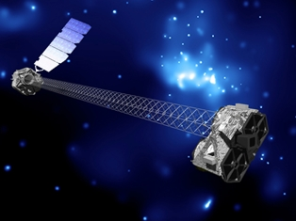
An illustration of the NuSTAR satellite observatory in orbit. The unique 10 metre long mast allows NuSTAR to focus high energy X-rays. Credit: NASA/JPL-Caltech.

Astronomers have found evidence for a large population of hidden supermassive black holes in the Universe.

Radio astronomers see black hole come to life (8 July 2015)
A team of radio astronomers, led by Dr Megan Argo of the Jodrell Bank Centre for Astrophysics, are watching a previously dormant black hole wake up in a dramatic display as material falls on to it for the first time for perhaps millions of years.

Massive black hole that outgrew its galaxy (9 July 2015)
Astronomers have spotted a super-sized black hole in the early universe that grew much faster than its host galaxy.
Fermi sees record flare from a black hole in a distant galaxy (10 July 2015)
Five billion years ago, a great disturbance rocked a region near the monster black hole at the centre of galaxy 3C 279.
Archive data reveals clues about black holes’ diet (23 July 2015)
Using archival data from the Sloan Digital Sky Survey, and the XMM-Newton and Chandra X-ray telescopes, a team of astronomers have discovered a gigantic black hole, which is probably destroying and devouring a massive star in its vicinity.

BROWN DWARFS
Brown dwarfs, stars share formation process (23 July 2015)
Astronomers using the Karl G. Jansky Very Large Array (VLA) have discovered jets of material ejected by still-forming young brown dwarfs.
Brown dwarfs host powerful auroral displays (29 July 2015)
Brown dwarfs are relatively cool, dim objects that are difficult to detect and hard to classify.

COMET
Comet sinkholes generate jets (1 July 2015)
A number of the dust jets emerging from Rosetta’s comet can be traced back to active pits that were likely formed by a sudden collapse of the surface.

New communication with Philae – commands executed successfully (10 July 2015)
The Philae lander communicated with the Rosetta orbiter again between 19:45 and 20:07 CEST on 9 July 2015 and transmitted measurement data from the COmet Nucleus Sounding Experiment by Radiowave Transmission (CONSERT) instrument.
Headache for Philae (20 July 2015)
On 9 July 2015 at 19:45 CEST, Philae reported back to the team at the German Aerospace Center (Deutsches Zentrum für Luft- und Raumfahrt; DLR) Lander Control Center (LCC) – only to then go back to 'silent mode'.
Churyumov-Gerasimenko: almost like firn and shaped by 'hail' (30 July 2015)
On 12 November 2014, as the Philae lander slowly descended onto Comet 67P/Churyumov-Gerasimenko, the first instruments on board began to take measurements.

DARK MATTER
Dark matter map begins to reveal the universe's early history (1 July 2015)
Researchers from the National Astronomical Observatory of Japan (NAOJ), the University of Tokyo and other institutions have begun a wide-area survey of the distribution of dark matter in the universe using Hyper Suprime-Cam, a new wide-field camera installed on the Subaru Telescope in Hawai'i.

The dark side of galactic radio jets (7 July 2015)
Cosmic microwave radiation points to invisible ‘dark matter’, marking the spot where jets of material travel at near light speed, according to an international team of astronomers.

Huge new survey to shine light on dark matter (9 July 2015)
The first results have been released from a major new dark matter survey of the southern skies using ESO’s VLT Survey Telescope (VST) at the Paranal Observatory in Chile.

Dead galaxies in Coma Cluster may be packed with dark matter (21 July 2015)
Galaxies in a cluster roughly 300 million light years from Earth could contain as much as 100 times more dark matter than visible matter, according to an Australian study.

EARTH

Seven ESA satellites team up to explore Earth's magnetic field (1 July 2015)
For the first time ever, two of ESA's flagship space missions – Cluster and Swarm – have joined forces to simultaneously measure the properties of Earth's magnetic field at two different altitudes.
Surfer-shaped waves in near-Earth space (8 July 2015)
The universe overflows with repeating patterns. From the smallest cells to the largest galaxies, scientists are often rewarded by observing similar patterns in vastly different places.
ESA teams ready for Europe's next weather satellite (9 July 2015)
Ground control teams are ready to shepherd Europe’s next weather satellite through its critical first days in orbit, ensuring it is working and healthy in the harsh environment of space.
Discovery of zebra stripes in space resolves a half-century mystery (14 July 2015)
In the 1960s, NASA launched six satellites to study the Earth’s atmosphere, magnetosphere and the space between Earth and the moon.

Why we live on Earth and not Venus (21 July 2015) Compared to its celestial neighbours Venus and Mars, Earth is a pretty habitable place.

Satellites peer into rock 50 miles beneath Tibetan Plateau (21 July 2015)
Gravity data captured by satellite has allowed researchers to take a closer look at the geology deep beneath the Tibetan Plateau.
Searching for underground energy sources from space (27 July 2015)
Data from ESA’s GOCE gravity satellite are being used to improve models of Earth’s geology, indicating the potential locations of subsurface energy sources.
MMS formation will give unique look at magnetic reconnection (29 July 2015)
On July 9, 2015 the four spacecraft of NASA’s Magnetospheric Multiscale, or MMS, mission began flying in a pyramid shape for the first time.

EXOPLANETS
Observing the birth of a planet (1 July 2015)
Astronomers at ETH Zurich have confirmed the existence of a young giant gas planet still embedded in the midst of the disk of gas and dust surrounding its parent star.
Astronomers see pebbles poised to make planets (5 July 2015)
A team of astronomers led from St Andrews and Manchester universities have announced the discovery of a ring of rocks circling a very young star.

Bricks to build an Earth found in every planetary system (8 July 2015)
Earth-like planets orbiting other stars in the Milky Way are three times more likely to have the same type of minerals as Earth than astronomers had previously thought.
Jupiter twin discovered around solar twin (15 July 2015)
An international group of astronomers has used the ESO 3.6-metre telescope to identify a planet just like Jupiter orbiting at the same distance from a Sun-like star, HIP 11915.
The planetary sweet spot (20 July 2015)
Planet Earth is situated in what astronomers call the Goldilocks Zone — a sweet spot in a solar system where a planet’s surface temperature is neither too hot nor too cold.

Kepler discovers bigger, older cousin to Earth (23 July 2015)
NASA's Kepler mission has confirmed the first near-Earth-size planet in the “habitable zone” around a sun-like star.
Telescopes team up to find distant Uranus-sized planet through microlensing (30 July 2015)
NASA's Hubble Space Telescope and the W. M. Keck Observatory in Hawaii have made independent confirmations of an exoplanet orbiting far from its central star.

Spitzer confirms closest rocky exoplanet (30 July 2015)
Using NASA's Spitzer Space Telescope, astronomers have confirmed the discovery of the nearest rocky planet outside our solar system, larger than Earth and a potential gold mine of science data.
Exceptional planetary system discovered in Cassiopeia (30 July 2015)
Astronomers from the University of Geneva (UNIGE) and members of the NCCR PlanetS have teased out a secret planetary system hiding in the arms of Cassiopeia, just 21 light years away from us.

GALAXIES
Fewer faint galaxies than expected (1 July 2015)
There may be far fewer galaxies further out in the Universe then might be expected, suggests a new study based on simulations conducted using the Blue Waters supercomputer at the National Center for Supercomputing Applications, with resulting data transferred to SDSC Cloud at the San Diego Supercomputer Center at the University of California, San Diego, for future analysis.
Small cosmic ‘fish’ points to big haul for SKA Pathfinder (5 July 2015)
A wisp of cosmic radio waves, emitted before our solar system was born, shows that a new radio telescope will be able to detect galaxies other telescopes can’t.

What happens when cosmic giants meet galactic dwarfs? (13 July 2015)
When two different sized galaxies smash together, the larger galaxy stops the smaller one making new stars, according to a study of more than 20,000 merging galaxies.
Dust pillars of destruction reveal impact of cosmic wind on galaxy evolution (27 July 2015) Astronomers have long known that powerful cosmic winds can sometimes blow through galaxies, sweeping out interstellar material and stopping future star formation.

Densest galaxies known discovered (27 July 2015)
Two undergraduates at San José State University have discovered two galaxies that are the densest known.

GAMMA-RAY BURST
Biggest explosions in the universe powered by strongest magnets (8 July 2015)
Observations from ESO’s La Silla and Paranal Observatories in Chile have for the first time demonstrated a link between a very long-lasting burst of gamma rays and an unusually bright supernova explosion.

GRAVITATIONAL WAVES

Dense star clusters shown as binary black hole factories (29 July 2015)
The coalescence of two black holes -- a very violent and exotic event -- is one of the most sought-after observations of modern astronomy.
HUMANS IN SPACE
Working out in artificial gravity (2 July 2015)
Astronauts on the International Space Station (ISS) have a number of exercise options, including a mechanical bicycle bolted to the floor, a weightlifting machine strapped to the wall, and a strap-down treadmill.
NASA selects astronauts for first U.S. commercial spaceflights (9 July 2015)
NASA has selected four astronauts to train and prepare for commercial spaceflights that will return American launches to U.S. soil and further open up low-Earth orbit transportation to the private sector.
Lack of consideration for human factors led to in-flight breakup of SpaceShipTwo (28 July 2015)
The National Transportation Safety Board determined the cause of the Oct. 31, 2014 in-flight breakup of SpaceShipTwo, was Scaled Composite’s failure to consider and protect against human error and the co-pilot’s premature unlocking of the spaceship’s feather system as a result of time pressure and vibration and loads that he had not recently experienced.

INTERNATIONAL SPACE STATION
Next International Space Station crew launch (15 July 2015)
The next three crew members bound for the International Space Station are set to launch Wednesday, July 22 and will arrive at the orbiting laboratory less than six hours later.
Robotic servicing demonstrations continue onboard the Space Station (20 July 2015)
NASA's Robotic Refueling Mission (RRM), a ground-breaking demonstration of new satellite-servicing technologies and techniques, recently resumed operations on the space station after a two-year hiatus.
Launch, docking returns International Space Station crew to full strength (22 July 2015)
Three crew members representing the United States, Russia and Japan have arrived at the International Space Station to continue important research that advances NASA's journey to Mars while making discoveries that can benefit all of humanity.
Space Kombucha in the search for life and its origins (29 July 2015)
You might know it as a drink for hipsters or as an ancient brew drunk for centuries in Eurasia, but the culture that ferments sugary tea into Kombucha is going around the world.

MARS
Curiosity rover finds evidence of Mars’ primitive continental crust (13 July 2015)
The ChemCam laser instrument on NASA’s Curiosity rover has turned its beam onto some unusually light-colored rocks on Mars, and the results are surprisingly similar to Earth’s granitic continental crust rocks.
Mars orbiter preparing for Mars lander's 2016 arrival (28 July 2015)
With its biggest orbit manoeuver since 2006, NASA's Mars Reconnaissance Orbiter (MRO) will prepare this week for the arrival of NASA's next Mars lander, InSight, next year.

MISCELLANEOUS
Flags are raised at ESA's first UK centre (9 July 2015)
Jan Woerner, ESA Director General, and Jo Johnson, UK Minister of State for Universities and Science, today watched ESA Member States’ flags rise for the first time at the Agency’s first centre in the UK.

NEPTUNE
Neptune’s badly behaved magnetic field (7 July 2015)
Combining 26-year old data with supercomputer simulations, a team of scientists at Imperial College London have modelled Neptune’s magnetic field in detail for the first time.

PLUTO
New Horizons spacecraft stays the course to Pluto (1 July 2015)
NASA's New Horizons spacecraft is getting a final "all clear" as it speeds closer to its historic July 14 flyby of Pluto and the dwarf planet's five moons.
New Horizons colour images reveal two distinct faces of Pluto (1 July 2015)
New colour images from NASA's New Horizons spacecraft show two very different faces of the mysterious dwarf planet, one with a series of intriguing spots along the equator that are evenly spaced.
New Horizons plans July 7 return to normal science operations (5 July 2015)
NASA's New Horizons mission is returning to normal science operations after a July 4 anomaly and remains on track for its July 14 flyby of Pluto.
New Horizons map of Pluto (7 July 2015)
This is the latest map of Pluto created from images taken from June 27 to July 3 by the Long Range Reconnaissance Imager (LORRI) on New Horizons, combined with lower-resolution colour data from the spacecraft’s Ralph instrument.
Scientists simulate the space environment during New Horizons flyby (10 July 2015)
When destined to stay close to Earth, spacecraft often must withstand the hazards of our space environment.
Last portrait of Pluto's puzzling spots (11 July 2015)
Three billion miles from Earth and just two and a half million miles from Pluto, NASA’s New Horizons spacecraft has taken its best image of four dark spots that continue to captivate.

New Horizons safe after Pluto flyby (15 July 2015)
NASA’s New Horizons spacecraft phoned home just before 9 p.m. EDT Tuesday to tell the mission team and the world it had accomplished the historic first-ever flyby of Pluto.

Pluto: the ice plot thickens (15 July 2015)

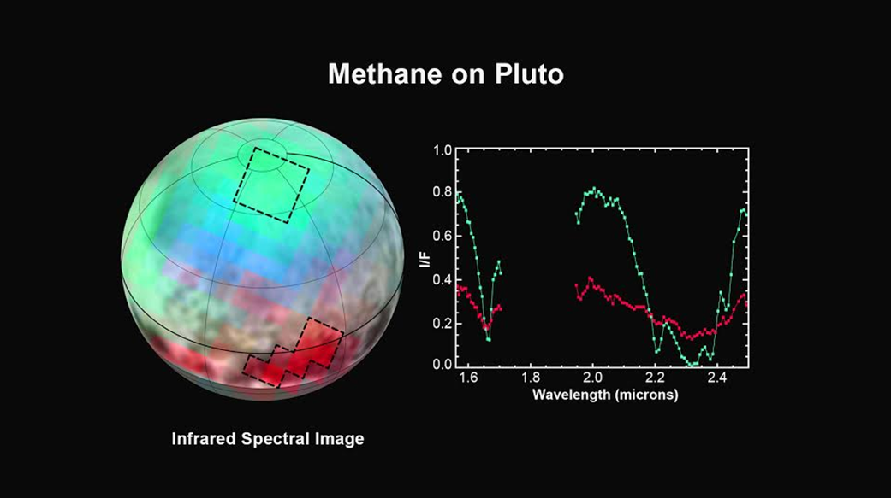
Image Credit: NASA-JHUAPL-SwRI﻿

The latest spectra from New Horizons Ralph instrument reveal an abundance of methane ice, but with striking differences from place to place across the frozen surface of Pluto.

The icy mountains of Pluto (15 July 2015)
New close-up images of a region near Pluto’s equator reveal a giant surprise: a range of youthful mountains rising as high as 11,000 feet (3,500 meters) above the surface of the icy body.
Frozen plains in the heart of Pluto’s 'Heart' (17 July 2015)
In the latest data from NASA’s New Horizons spacecraft, a new close-up image of Pluto reveals a vast, craterless plain that appears to be no more than 100 million years old, and is possibly still being shaped by geologic processes.

Pluto’s extended atmosphere (17 July 2015)
Scientists working with NASA’s New Horizons spacecraft have observed Pluto’s atmosphere as far as 1,000 miles (1,600 kilometers) above the surface of the planet, demonstrating that Pluto’s nitrogen-rich atmosphere is quite extended.
Cold, dense region of atmospheric ions behind Pluto (17 July 2015)
New Horizons has discovered a region of cold, dense ionized gas tens of thousands of miles beyond Pluto -- the planet’s atmosphere being stripped away by the solar wind and lost to space.
New Horizons team finds haze, flowing ice on Pluto (24 July 2015)
Flowing ice and a surprising extended haze are among the newest discoveries from NASA’s New Horizons mission, which reveal distant Pluto to be an icy world of wonders.

PULSARS
Fireworks from rare stellar encounter predicted in 2018 (2 July 2015)
Astronomers are gearing up for high-energy fireworks coming in early 2018, when a stellar remnant the size of a city meets one of the brightest stars in our galaxy.
Pulsar punches hole in stellar disk (22 July 2015)
A fast-moving pulsar appears to have punched a hole in a disk of gas around its companion star and launched a fragment of the disk outward at a speed of about 40 million miles per hour.

SATURN AND MOONS
Unusual red arcs spotted on icy Saturn moon (29 July 2015)
Like graffiti sprayed by an unknown artist, unexplained arc-shaped, reddish streaks are visible on the surface of Saturn's icy moon Tethys in new, enhanced-colour images from NASA's Cassini spacecraft.

STARS AND STAR CLUSTERS
A five star, doubly-eclipsing star system (7 July 2015)
Astronomers at the Open University have discovered the first quintuple star system containing two eclipsing binary stars.
How neutron star kicks can break up clusters (8 July 2015)
A supernova explosion at the end of a large star’s life can leave the collapsed core, or neutron star, hurtling away from its dust and gas envelope at hundreds of kilometres per second.

One in a billion star (16 July 2015)
The Gaia satellite has discovered a unique binary system where one star is ‘eating’ the other, but neither star has any hydrogen, the most common element in the Universe.
Starry surprise in the bulge: encounter of a halo passer-by (21 July 2015)
A team led by Andrea Kunder from the Leibniz Institute for Astrophysics Potsdam (AIP) measured the velocity of a sample of 100 old RR Lyrae stars thought to reside in the Galactic bulge, the central group of stars found in most Galaxies.
First detection of lithium from an exploding star (29 July 2015)
The chemical element lithium has been found for the first time in material ejected by a nova.
Unlocking the secrets of stars through aluminium (29 July 2015)
Physicists at the University of York have revealed a new understanding of nucleosynthesis in stars, providing insight into the role massive stars play in the evolution of the Milky Way and the origins of the Solar System.
Stars in Milky Way have moved (30 July 2015)
New Mexico State University researchers are part of a team of scientists with the Sloan Digital Sky Survey (SDSS) who created a new map of the Milky Way that shows nearly a third of the stars have dramatically changed their obits.

SUN
Does the solar magnetic field show a North-South divide? (7 July 2015)
A study of jets travelling through the Sun’s corona at speeds between 200-500 kilometres per second has shown that the fast-moving columns of plasma are deflected much more strongly by the Sun’s magnetic field in the northern hemisphere than in the southern hemisphere.

Curiosity Mars rover tracks sunspots (10 July 2015)
While busily investigating bedrock types on Mars' Mount Sharp and preparing for a drill test, NASA's Curiosity Mars rover has also been looking up frequently to monitor sunspots on the face of the sun that is turned away from Earth.
Lobster-eye imager detects soft x-ray emissions (28 July 2015)
Solar winds are known for powering dangerous space weather events near Earth, which, in turn, endangers space assets.

SUPERNOVA
Colliding red giant prime suspect for luminous red nova outburst (8 July 2015)
Observations of a rare astronomical phenomenon, called a luminous red nova, suggest that this bright outburst was caused by a red giant colliding with another star.
Irregular heartbeat of the Sun driven by double dynamo (9 July 2015)
A new model of the Sun’s solar cycle is producing unprecedentedly accurate predictions of irregularities within the Sun’s 11-year heartbeat.
Erupting every year and on the brink of catastrophe: the ‘best candidate’ supernova (9 July 2015) Using the robotic Liverpool Telescope, an international team of scientists has found what looks like the best pre-explosion candidate yet for a ‘type 1a’ supernova, where a massive and extremely dense star in the Andromeda Galaxy is dragging material away from its companion.

New 3-D model could solve supernova mystery (21 July 2015)
Giant stars die a violent death. After a life of several million years, they collapse into themselves and then explode in what is known as a supernova.

TECHNOLOGY AND TECHNOLOGY TRANSFER
Analysing galaxy images with artificial intelligence (7 July 2015)
A team of astronomers and computer scientists at the University of Hertfordshire have taught a machine to 'see' astronomical images.
Space cameras as early warning systems for forest fires (17 July 2015)
At 13:28 CEST on 2 July 2015, the alarm in the Wünsdorf forest fire centre went off. Smoke had been seen rising from the forest district in Baruth.

Designing integrated circuits for Venus rover (29 July 2015)
The surface of Venus is the most hostile environment in the solar system.

UNIVERSE
Green Bank Telescope joins 'Breakthrough Listen' to vastly accelerate search for intelligent life in the universe (20 July 2015)
The National Science Foundation’s Green Bank Telescope (GBT) will join in the most powerful, comprehensive, and intensive scientific search ever for signs of intelligent life in the Universe.

VENUS
Studying the atmosphere of Venus through transit images (9 July 2015)
A group of scientists have used the Venus transit - a very rare event where a planet passes between Earth and the sun, appearing to us as a dark dot steadily making its way across the sun’s bright face - to make measurements of how the Venusian atmosphere absorbs different kinds of light.
Pat Williams. July 2015

